Phase 4

Lesson 1

Practice Assisted 4

Code:

Nav.html:

<!DOCTYPE html>

<html>

  <head>

    <meta name="viewport" content="width=device-width, initial-scale=1">

  <link rel="stylesheet" href="https://stackpath.bootstrapcdn.com/bootstrap/4.1.3/css/bootstrap.min.css" integrity="sha384-MCw98/SFnGE8fJT3GXwEOngsV7Zt27NXFoaoApmYm81iuXoPkFOJwJ8ERdknLPMO" crossorigin="anonymous">

    <script src="https://ajax.googleapis.com/ajax/libs/jquery/3.2.1/jquery.min.js"></script>

    <script src="https://maxcdn.bootstrapcdn.com/bootstrap/3.3.7/js/bootstrap.min.js"></script>

  </head>

  <body>

    <nav class="navbar navbar-expand-md">

      <a class="navbar-brand" href="#"><img src="images/noodle.png" alt=""></a>

      <button class="navbar-toggler navbar-dark" type="button" data-toggle="collapse" data-target="#main-navigation">

        <span class="navbar-toggler-icon"></span>

      </button>

      <div class="collapse navbar-collapse" id="main-navigation">

        <ul class="navbar-nav">

          <li class="nav-item">

            <a class="nav-link" href="index.html">Home</a>

          </li>

          <li class="nav-item">

            <a class="nav-link" href="form.html">Contact</a>

          </li>

          <li class="nav-item">

            <a class="nav-link" href="page.html">Pagination</a>

          </li>

        </ul>

      </div>

    </nav>

    <p>The 'nav' tag is used to define a block of links for navigation, for the current page, or for other pages.</p>

  </body>

</html>

Output:

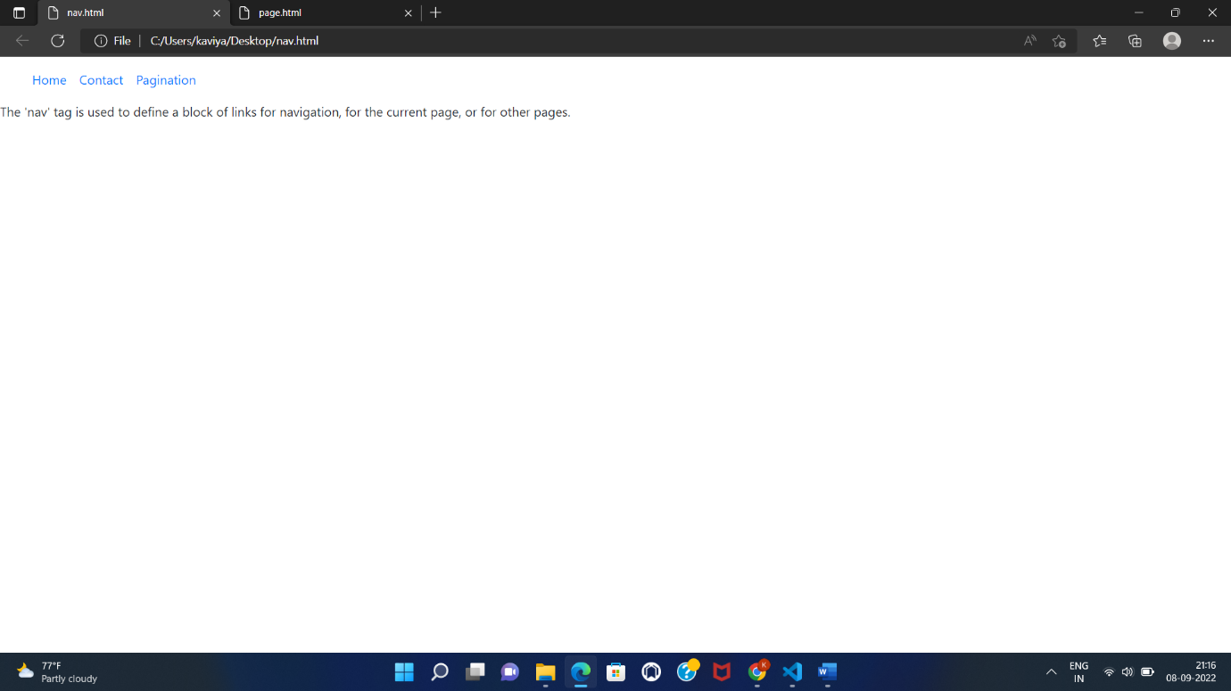

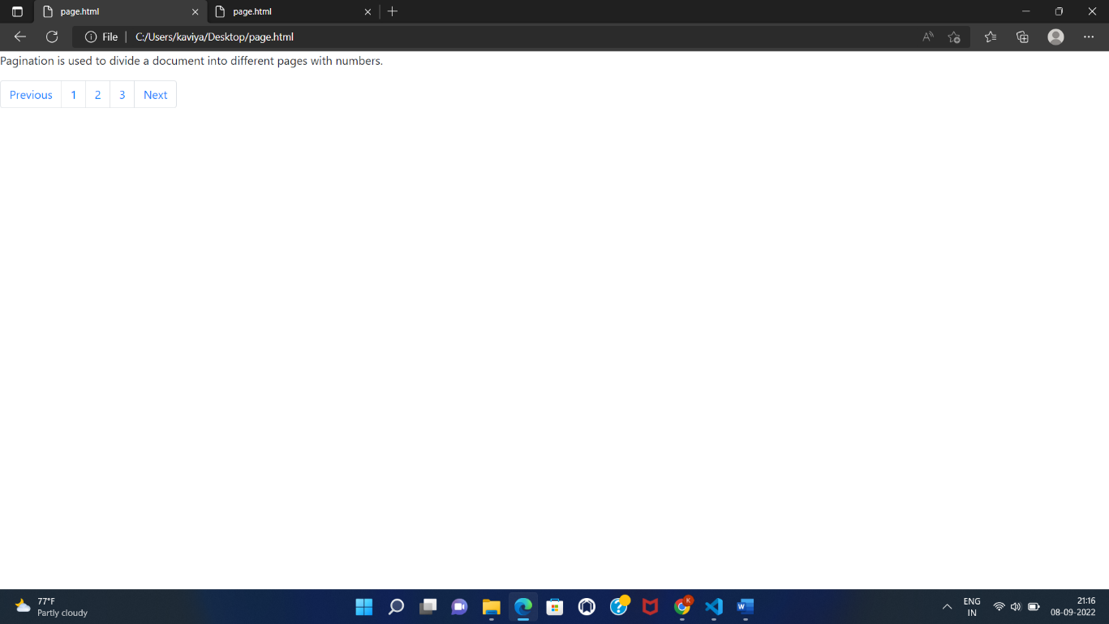

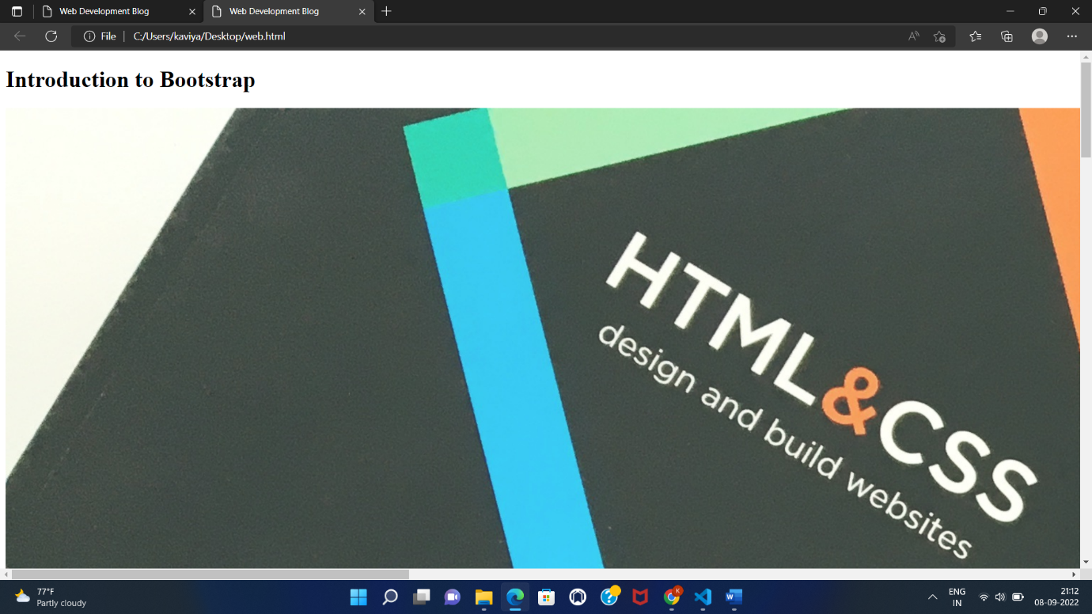

Page.html:

<!DOCTYPE html>

<html>

  <head>

    <meta name="viewport" content="width=device-width, initial-scale=1">

  <link rel="stylesheet" href="https://stackpath.bootstrapcdn.com/bootstrap/4.1.3/css/bootstrap.min.css" integrity="sha384-MCw98/SFnGE8fJT3GXwEOngsV7Zt27NXFoaoApmYm81iuXoPkFOJwJ8ERdknLPMO" crossorigin="anonymous">

    <script src="https://ajax.googleapis.com/ajax/libs/jquery/3.2.1/jquery.min.js"></script>

    <script src="https://maxcdn.bootstrapcdn.com/bootstrap/3.3.7/js/bootstrap.min.js"></script>

  </head>

  <body>

    <p>Pagination is used to divide a document into different pages with numbers.</p>

    <nav aria-label="Pagination Demo">

      <ul class="pagination">

        <li class="page-item"><a class="page-link" href="#">Previous</a></li>

        <li class="page-item"><a class="page-link" href="index.html">1</a></li>

        <li class="page-item"><a class="page-link" href="form.html">2</a></li>

        <li class="page-item"><a class="page-link" href="nav.html">3</a></li>

        <li class="page-item"><a class="page-link" href="#">Next</a></li>

      </ul>

    </nav>

  </body>

</html>

OUTPUT:

